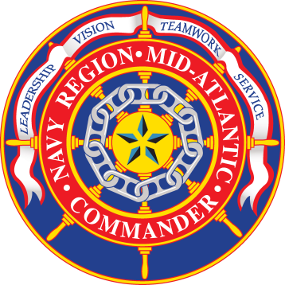

**Department of the Navy**

**Navy Region Mid-Atlantic**

**Public Affairs Office**

**1510 Gilbert St., Ste. 207**

**Norfolk, VA 23511**

**Tel: (757) 322-2853**

**Fax: (757) 445-1953**

NEWS MEDIA ADVISORY 25-02 January 29, 2025

**Hearing set for Sailor charged in death of Sailor at Naval Weapons Station Yorktown**

**NORFOLK, Va.** – Charges have been formally preferred against a U.S. Navy Sailor assigned to Naval Weapons Station Yorktown in connection with the death of Master-at-Arms Third Class Lyndon Joel Cosgriff-Flax, who was killed in a boating incident on the York River on April 28, 2024. The Article 32 hearing will begin tomorrow at 1:00 p.m.

The sailor, who will remain unnamed until charges have been referred, has been charged with negligent homicide in the death of Cosgriff-Flax, making a false official statement, and two counts of dereliction of duty.

Media interested in attending the preliminary hearing should contact the Navy Region Mid-Atlantic Public Affairs Office by 4 p.m. today.

###

**NOTE TO MEDIA:** For additional information on the military justice process and courtroom decorum, visit www.cnic.navy.mil/regions/cnrma/news/media/